**INSTITUTE OF ENGINEERING**

ADVANCED COLLEGE OF ENGINEERING AND MANAGEMENT

Kupondole, Lalitpur

**(AFFILIATED TO TRIBHUVAN UNIVERSITY)**



Lab no:4

Subject: Computer Network

**Submitted By: Submitted To:**

Department of Computer

and

Electronics Engineering

Name: Sameep Dhakal

Roll no: ACE074BCT063

Date: 09/07/2021

# Lab 4

# Title: Network Address Translation (NAT)

# Objective:

* To Learn about the translating the Internet protocol version 4 addresses of computers

# Introduction:

Network address translation (NAT) provides a method for translating the Internet Protocol version 4 (IPv4) addresses of computers on one network into IPv4 addresses of computers on a different network. A NAT-enabled IP router deployed at the boundary where a private network, such as a corporate network, meets a public network, such as the Internet, allows computers on the private network to access computers on the public network by providing this translation service.

# Design:

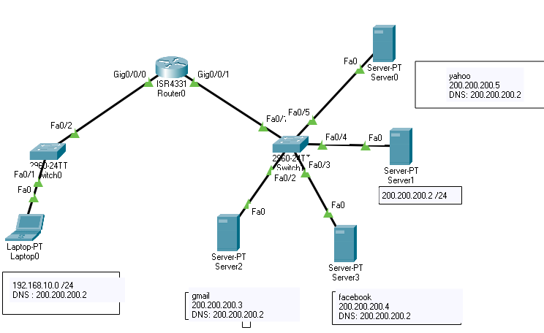

There are four servers where server1 is the main server for hosting and router 4331 is used where Nat is done for translation of Ip address to connect the severs.

# Procedure:

1. First the required tools are selected.
2. The required ports of the routers were turned on.
3. Then th Ip and subnet mask of the laptop, router and server was set
   1. For laptop, server this was gone by going to the desktop and Ip configurations
   2. For routers this was done by going to the configuration and selecting the required port
4. Required connections were made between the routers and laptops
5. The domain names were given to each server.

# Code

Router0>enable

Router0#config terminal

Router0 (config)#enable password Router0

Router0 (config)#interface gigt0/0/0

Router0 (config-if)#ip address 192.168.10.1 255.255.255.0

Router0 (config-if)#ip nat inside

Router0 (config-if)#no shut

Router0 (config-if)#no shutdown

Router0 (config-if)#no shutdown

Router0 (config-if)#exit

Router0 (config)#inter

Router0 (config)#interface gig0/0/1

Router0 (config-if)#ip address 200.200.200.1 255.255.255.0

Router0 (config-if)#ip nat outside

Router0 (config-if)#no shutdown

Router0 (config-if)#exit

Router0 (config)#ip nat inside source static 192.168.10.1 200.200.200.1

Router0 (config)#exit

# Output:

Server1 Domain records

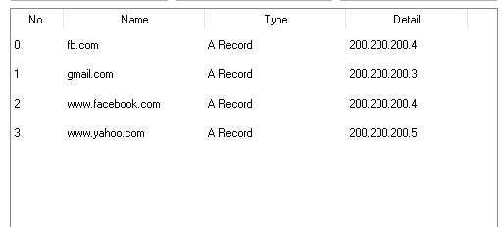

Laptop1 to server0

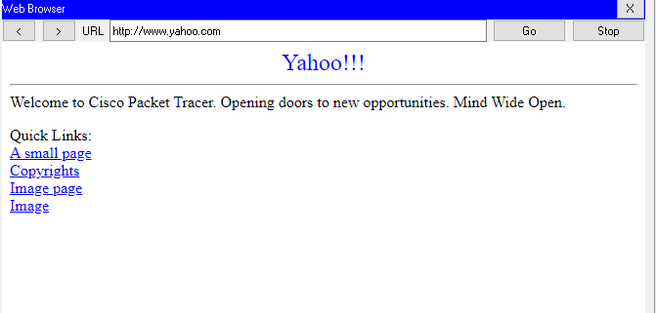

Laptop1 to server2

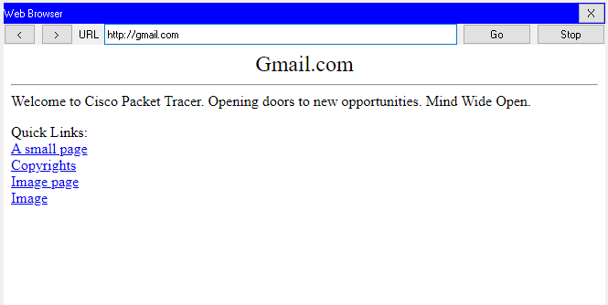

Laptop1 to server3

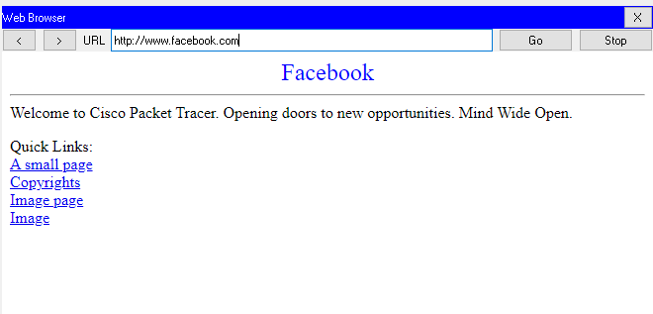

# Result and Conclusion

In this lab we were able to distribute the load to different servers by setting the domain names on different servers and we were able to translate the Ip address of on computer network to another.